Paper Bridge

Subject:  Related Subjects: | Grade Level(s):  Length of Lesson: | Type: Inquiry / Design / Project  Keywords:

Lesson Overview
Use this section to describe at a high level what the lesson is. Should be no more than 3-4 lines.

Lesson Focus
What is the central question or phenomenon being investigated? What problem are they trying to solve?

Lesson Objective(s) | By the end of this lesson, students will…  - Learn the concepts of attraction, repulsion, friction, polarity, and charge.

Lesson Timing

5 minutes | Introduce the Lesson
30 minutes | ...

Materials | - Material 1 (# per student, per group of # students, per class)
Instructor Prep | - Step 1
Related Resources | - List related lessons/ppts etc available from USC or outside, trusted orgs

Lesson Plan

Introduction
Introduce students to the learning goals and make connections to past and present learning experiences. Stimulate interest and prompt students to identify their own questions about the topic. This can link the lesson to real world examples, introduce associated STEM careers, and assess their prior knowledge on the topic.

- Step 1

Procedure
- Make a bridge that spans 6 inches that can hold the most weight

- 2 sheets card stock and 2 feet of tape

- A maximum of 50% of a paper’s total flat surface may be taped. Both sides of each stick can be considered in the 50% calculation. e.g. 100% of side 1 and 0% of side 2; 75% of side 1 and 25% of side 2.

- Tape must only be used at joints, and must not be used on the surface of the roadway.

- The bridge must be open at the top to allow insertion of testing apparatus. Bridge must have 1cm gap in the center to accommodate testing apparatus (This is only for the classroom testing apparatus and will not be the case in the actual competition).

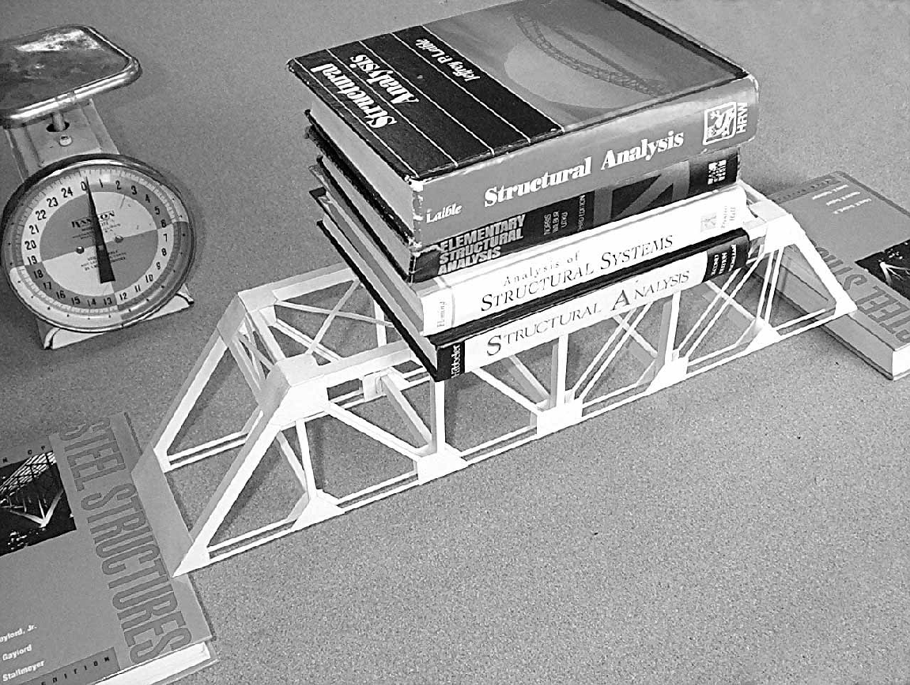 | 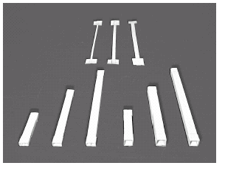
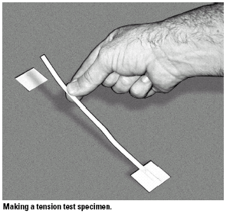 | 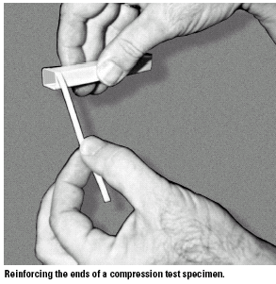
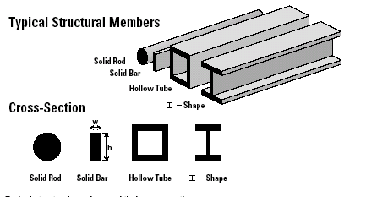
I-beams are illegal
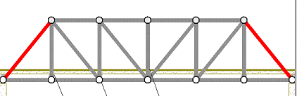

Wrap-up
End the lesson with some final discussions about what students designed/discovered. Connect their activity back to the focus question/problem, real world examples, and STEM careers.

Also include notes about any special cleanup considerations

Lesson Background for Teachers

Suggested Real-World STEM Connections
- List possible related Role Models in STEM (with details and links to more reading). Give suggestions for examples of scientists/engineers who are from underrepresented groups in STEM in related careers.
- List related real-world engineering problems and examples

Lesson Variations and Options
Include descriptions of alternative methods or ways to present things.

Explanation
Describe the background concepts and explanations behind the lesson. This can be more in depth than a teacher/instructor would actually share with students.

Key Concepts and Vocabulary
- Word 1: Grade Appropriate Definition
- Word 2: Grade Appropriate Definition

Safety Notes
- Safety instruction

